# Lesson 80 单词讲解

1. palace n. 宫殿

the Crystal Palace

the Buckingham Palace the Palace Museum the Summer Palace

extraordinary [ik'strɔ:dinəri] a.不平常的.非凡的

1. exhibition n. 展览

the Great Exhibition

iron ['aiən] n.铁

various ['veəriəs] a.各种各样的

1. machinery n. 机器a piece of machinery a machine
2. display n. 展览，陈列on display ／on show
3. steam n. 蒸汽

a steam hammer steam boats

1. profit n. 利润

cost n. 成本

college ['kɔlidʒ] n.学院

# Lesson 80 课文&语法讲解

本课重点:

复习形容词副词的比较级／最高级／原级比较

1. Perhaps the most extraordinary building of the nineteeth century was the Crystal Palace, which was built in Hyde Park for the Great Exhibition of 1851.

1. The Crystal Palace was different from all other buildings in the world, for it was made of iron and glass.

be different from … be the same as … be similar to …

be made of / from …

1. It was one of the biggest buildings of all time and a lot of people from many countries came to see it.
2. A great many goods were sent to the exhibition from various parts of the world.
3. There was also a great deal of machinery on display.
4. The most wonderful piece of machinery was Nasmyth’s steam hammer.
5. Though in those days, travelling was not as easy as it is today, steam boats carried thousands of visitors across the Channel from Europe.

… travelling was not as easy as it is today …

People are not so honest as before.

as they were.

as they used to be.

1. 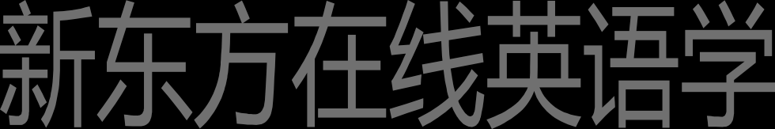There were six million visitors in all, and the profits from the exhibition were used to build museums and colleges.
2. It remained one of the most famous buildings in the world until it was burnt down in 1936.

# Lesson 80 知识拓展

补充内容: on 词组

on 词组

There was also a great deal of machinery on display.

The most wonderful piece of machinery on show was Nasmyth’s steam hammer.

on 词组

He has gone to France on business.

I didn’t catch the bus. I came here on foot.

I asked to see the manager on duty.

on 词组

On the whole, it has been a very successful year. On the average, I make six telephone calls a day.

on 词组

Look at the smoke. That building must be on fire.

I don’t think it was an accident. He did it on purpose.

I knew I had agreed to go with you, but on second thoughts, I should finish my work first.

on 词组

While the guard was , he heard a shot.

on duty

I’ve changed my mind. I’ll go by plane instead.

On second thoughts

on 词组

I think you dropped your handkerchief , so that he could pick it up.

on purpose

, 250,000 tourists visit this town each year.

On the average

补充内容: on 词组

